HIVE ARCHITECTURE

Hive Consists of Mainly 3 core parts

1. **Hive Clients**
2. **Hive Services**
3. **Hive Storage and Computing**

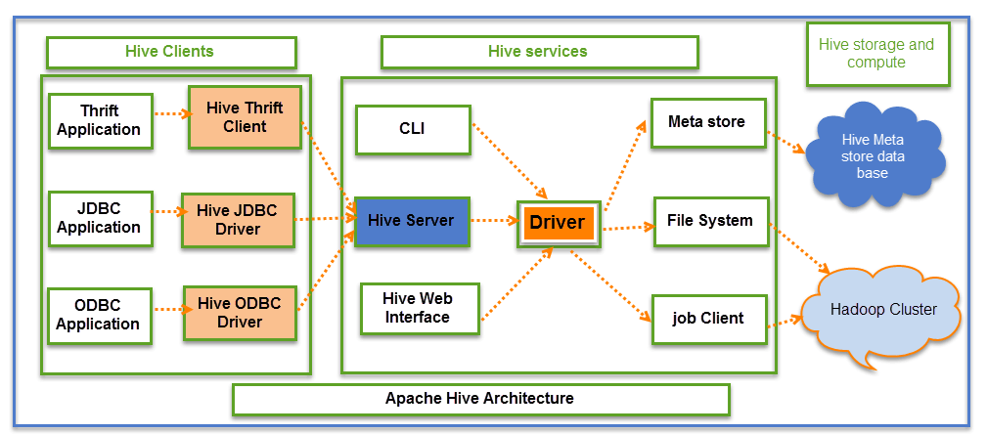

**Hive Clients:**

Hive provides different drivers for communication with a different type of applications. For Thrift based applications, it will provide Thrift client for communication.

For Java related applications, it provides JDBC Drivers. Other than any type of applications provided ODBC drivers. These Clients and drivers in turn again communicate with Hive server in the Hive services.

**Hive Services:**

Client interactions with Hive can be performed through Hive Services. If the client wants to perform any query related operations in Hive, it has to communicate through Hive Services.

CLI is the command line interface acts as Hive service for DDL (Data definition Language) operations. All drivers communicate with Hive server and to the main driver in Hive services as shown in above architecture diagram. Driver present in the Hive services represents the main driver, and it communicates all type of JDBC, ODBC, and other client specific applications. Driver will process those requests from different applications to meta store and field systems for further processing.

**Hive Storage and Computing:**

Hive services such as Meta store, File system, and Job Client in turn communicates with Hive storage and performs the following actions

* Metadata information of tables created in Hive is stored in Hive "Meta storage database".
* Query results and data loaded in the tables are going to be stored in Hadoop cluster on HDFS.